Cyber Security

# Installation Process of Virtual Box

1. Download Virtual Box 6.1.40 from <https://www.virtualbox.org/wiki/Download_Old_Builds_6_1>.

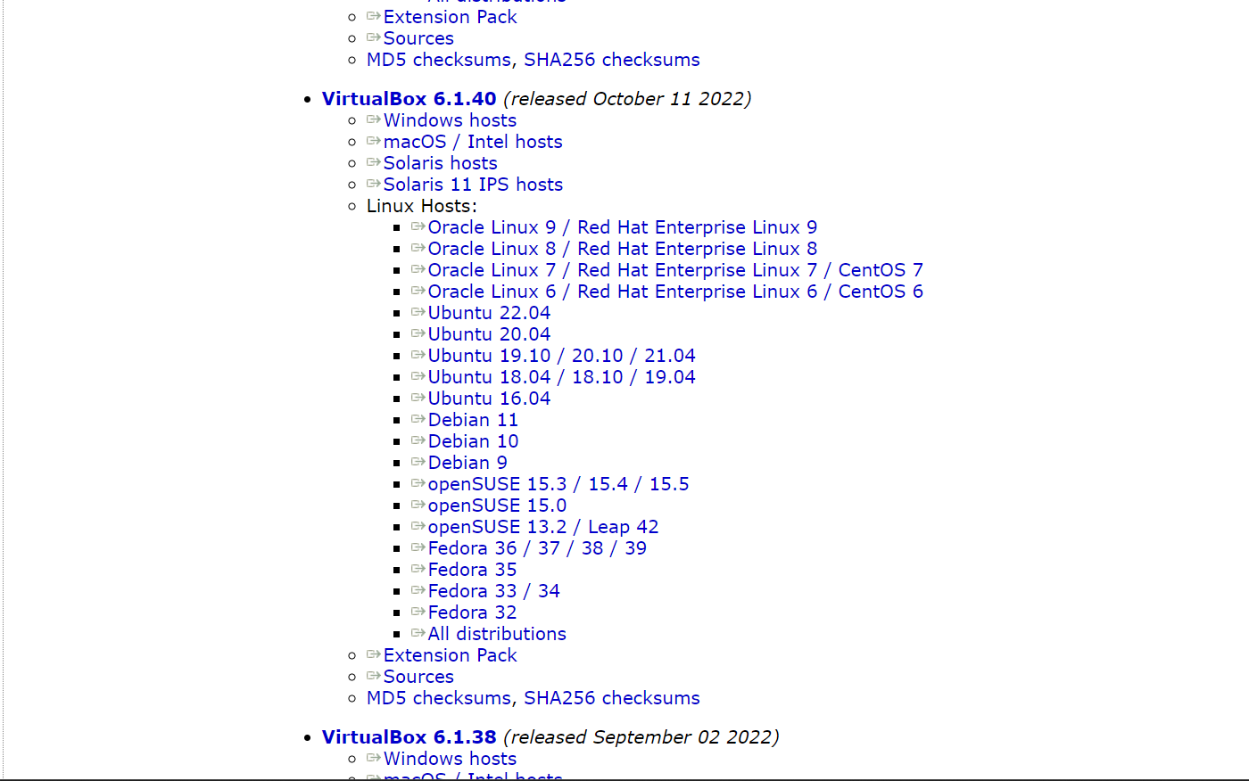

1. Download Kali Purple (recommended version) from <https://www.kali.org/get-kali/#kali-installer-images>.

